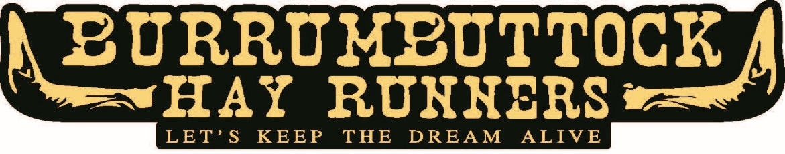

The Burrumbuttock Hay Runners are bringing a load of generously donated hay to
Ilfracombe, QLD to assist drought affected farmers.
Hay will be available on Friday 9th July 2021.
We will be setting up 3 depots in the area so please indicate which depot you wish to collect from
BALLOT FORM / EXPRESSION OF INTEREST

Name:
Property Name:
Farm Address:  (where would we deliver hay) | Town: Postcode:
Phone: |  | Mobile:
Email:
Preferred contact method:

I would like to collect my allocate from the following depot:

WINTON (Dolly Grant)

BOULIA (Jack Nelson) MUTTABURRA (Beau Deane)

What quantity of hay can you collect?

Minimum number of bales needed to make your trip viable? _______
(We can’t guarantee to allocate the minimum, but we will try)

Maximum number of bales you can collect? _______

Please note:
- Allocations will be made based on stock numbers once all applications are collated and we have confirmed the number of bales available.
Are you a primary producer? |  |  | Yes | No
What number of stock are you feeding? |  |  | Cattle ______ | Sheep ______
 |  |  | Horses ______ | Other ______  (Please specify)
I have read, understand and agree to the conditions outlined overleaf.

Signed: __________________________________ Date: _________________

PLEASE RETURN EXPRESSION OF INTEREST NO LATER THAN 30th June

ballot@hayrunners.com or PO BOX 24 Burrumbuttock NSW 2642

CONDITIONS

Completed expression of interest forms will be accepted until midnight 30th June 2021. Late forms will not be accepted.

NO VERBAL REQUESTS WILL BE ACCEPTED – FORM MUST BE COMPLETED FOR ANY EXPRESSION OF INTEREST

You must reside on a property in drought affected area.

We may need to do a ballot which means some people could miss out on hay. This will be determined by the number of applications we receive and the how much hay we have available. The way the ballot will be done is:
- As applications are received, they will be entered into a spreadsheet and assigned a number – starting with 1 and ending with the last application received by the due date. If 300 applications are received, then applications will be numbered 1 to 300 etc. A random number generator on the computer will be used to pick the numbers that will be removed from the ballot. This will ensure the process is fair. If we need to do a ballot, and you are balloted out I apologise in advance as I know you will be disappointed. Hopefully we will receive enough hay to meet all requests.

You will be notified of your allocation (and results of the ballot if one is done) after 30th June. As I am likely to receive in excess of 200 applications, I really prefer email as sending 250+ emails is easy, but making the same number of phone calls is very difficult.

Bales not collected by 5.00pm Sunday 11th July maybe re-allocated unless prior arrangement is made directly with Brendan or the depot contact.

While we do our very best, quality and quantity of hay cannot be guaranteed.

Brendan Farrell is the event organiser, he will review all expression of interest forms and allocate hay donations. All questions regarding allocation received should be directed to Brendan on 0439 322 605.

All thanks and acknowledgements to all the volunteers who make up the Burrumbuttock Hay Runners, the farmers who have donated the hay, the truckies who’ve donated their trucks and time to deliver the hay, all sponsors and people who have donated money towards the cost associated with bringing the hay to our farmers in need.
All hayrunners are 100% volunteers.

Note: If it rains the hay delivery maybe postponed. A new form will not be required and we’ll contact you soon as a new delivery date is arranged.

